DEMOCRACY & THE BIBLE

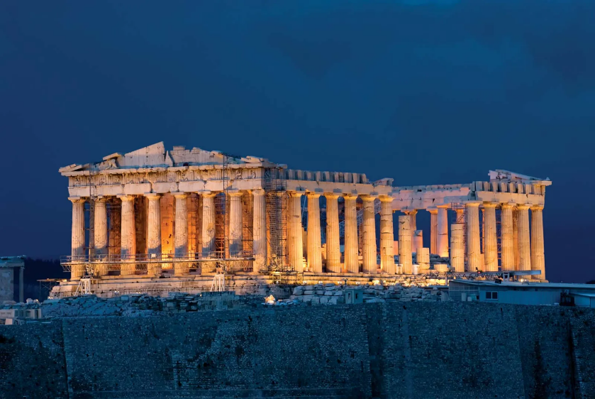

Are they compatible?

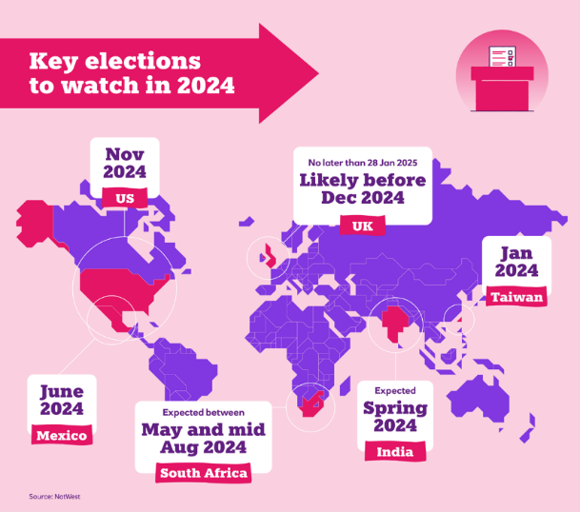
The Relevance of the subject to today – is that the two main English speaking nations in the West are supposed to be holding their national elections, this year - the United States of America, and the United Kingdom. The Prime Minister of the UK could call an early General election to determine the next Government, which would mean campaigning might start next month. In the United States the elections are scheduled to be held on Tuesday, November 5. The idea of elections and selecting leaders and political parties by majority vote, of all eligible citizens is a feature of what is known as Democracy. In the East, the growing superpower of China has a so-called social democracy led by the communist party. Russia, on the other hand pretends to be a democratic state but is in fact an Autocracy, being ruled by a Head of State where all opposition has been neutralised. Death of Navalny. Authoritarian regimes and Absolute monarchies are common in the Middle East, whereas Israel located in the middle of them all has a parliamentary democracy. The differences between the East and West ideologies of politics such as democracy is causing increasing friction and hostility. Democracy is held up by the West as being a beacon of human progress, and a bulwark of righteousness against the tyrannies of the axis of evil.
What is democracy?
The word democracy comes from the Greek word demos meaning people, and simply means 'rule by the people'. Democracy is often defined as a government of the people by the people and for the people. This country the United Kingdom is a liberal democracy. If constituents of a member of Parliament object to how he or she votes in the Government they have the option of voting someone else in to replace them. In this way even people on the street can have a voice and prove to be a deciding factor into what policies and political party become the ruling power. People believe that this system of government is the perfect answer, and the right way to go especially when comparing it to Afghanistan which is an autocracy ruled by the supreme mullah, advised by his clerics, where people are brutally suppressed and have no voice, where women are hidden away in the back rooms of houses, and education for girls banned, one fanatical strand of religion is compulsory. In that light, virtually any other system of government will look good.
However the aim of this talk is to show that even democracy – and in many ways – especially democracy is not compatible with Christian living, and has inherent flaws and is set to fail. This will bring about a collapse of Western society as we know it, just as dictatorships and autocracies will also fail and make way for a New World Order as the Bible predicts.
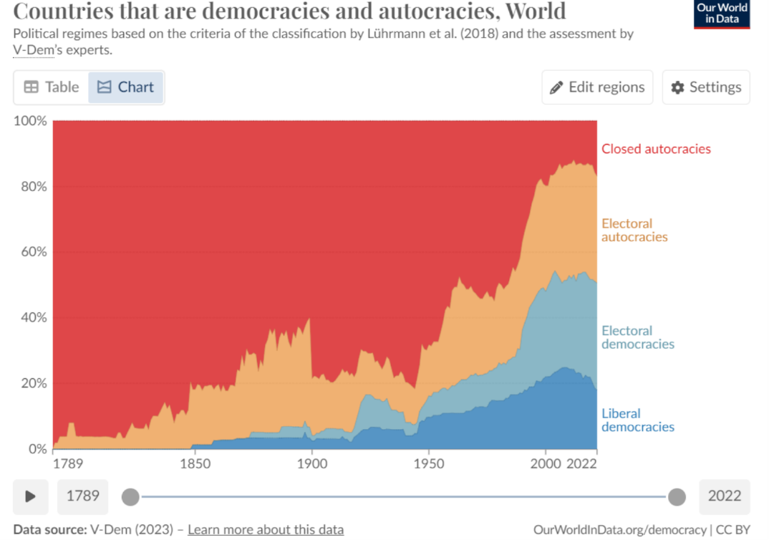
History of Democracy
To understand this, it is necessary to look at the history of Democracy. Democracy as a popular and widespread form of government is a relatively modern phenomenon. Please see chart in previous page.
There is quite of lot of information here, showing how back in the mid 18th century, the whole world was effectively ruled by autocracies, and then from the time of the 1789 as shown here, power of election was given to a few and the idea of just one person dictating government began to give way to power being held by an elected few, as time goes on into the modern era, we see how this notion spreads increasingly around the world, and then the popularity of democratic governments becomes increasingly common, so that today around half the world lives under a democratic system of some kind. What we notice though intriguingly, and it is something we will explore, is the marked downturn at the end of the graph there, and all of a sudden there is a drop off, with democratic countries gradually giving way to more autocratic systems.

Bible was the prime mover of democracy
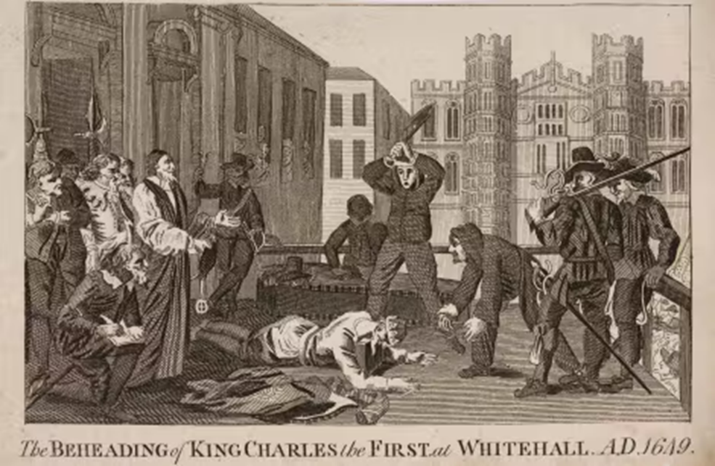
The concepts of democracy as a form of government are said to have originated in Athens around 508 BC. However modern democracy has its roots in Britain and then America in the 17th Century and was in fact an unexpected consequence of the King James Bible. This some may find quite astonishing, but it is a fact accepted by historians. The Bible was not accessible for many centuries to the common man, as it was written in Latin. The elites, aristocrats and the church- which was across Europe - the Roman Catholic Church insisted on the Bible only being in Latin to maintain its sacredness they claimed, and the common man needed priests to intercede for him and explain all that was necessary for their salvation. Populations were thus manipulated for generations to serve the interests of just a tiny few. However, when the Bible was translated into English much to the consternation of the church, and then authorised by King James, with the invention of the printing press it became accessible to all. Its teachings and ideas were a revelation, and caused a revolution. The common man realised he had been deceived and deluded, that authority did not belong to just a few elites. Under the leadership of Oliver Cromwell and the New Model Army, the so-called Divine Right of Kings to rule over the people was demolished when Charles 1st was beheaded, and power was ceded to the English Parliament. It was the reading of the Bible, the only book most people possessed, that gave people the knowledge and intellectual arguments to overthrow the status quo of existing hierarchies.
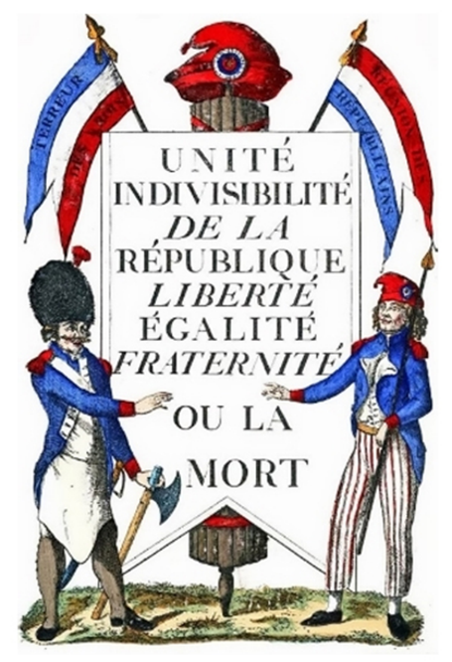
The Bible taught equality before God: Galatians 3:28: There is neither Jew nor Greek, there is neither bond nor free, there is neither male nor female: for ye are all one in Christ Jesus. If you had equality before God, then why not equality in government? These ideas were transported to America, from the Founding Fathers to hundreds of thousands of Puritans, and as time and events moved on, the Declaration of Independence in 1776 democracy had arrived “we hold these truths to be self-evident that all men are created equal that they are endowed by their creator with certain inalienable rights” Such ideas inspired the French Revolution in 1789, as well as crippling food shortages and bankruptcy of the French nation. It was this revolution where the common people who were known as the Third Estate overthrew the First Estate – aristocracy, and the Second Estate, the Roman Catholic Church, and power was seized by them setting up a National Assembly, The ideas of liberty, equality and Fraternity became their battle cry, and these ideas are the foundation of modern democracy. All from the translation of the King James Bible into mother tongues.

Democracy the beacon of human progress. Or is it?
The spirit of revolution with the ideology of the trinity of liberty, equality and fraternity swept across Europe overthrowing multiple governments. But after the Napoleonic wars, there followed nonstop warfare in Europe, with hardly a year of peace, punctuated by two world wars where millions perished. Democracy became more extreme and morphed into Communism, following the teachings of Marxism, and subsequent purges meant the deaths of even more millions. The overthrow of centuries of rule by an elite authority, resulted in chaos, misery and death for countless millions. Knowledge is power. But a little knowledge is dangerous thing. The translation of the Bible which was the cause of the education and liberation of a people and subsequent generation, did not bring about the very rich rewards the Holy Book promised. Because its contents were cherry picked. Human nature does not change. Just a different breed of men sought power - the underclass, they achieved power, and power corrupts, and as the adage goes absolute power corrupts absolutely.
The Bible says this: Romans 8:77 Because the carnal mind is enmity against God: for it is not subject to the law of God, neither indeed can be.
Democracy is not the beacon of human progress. Why not?
Because God is left out.
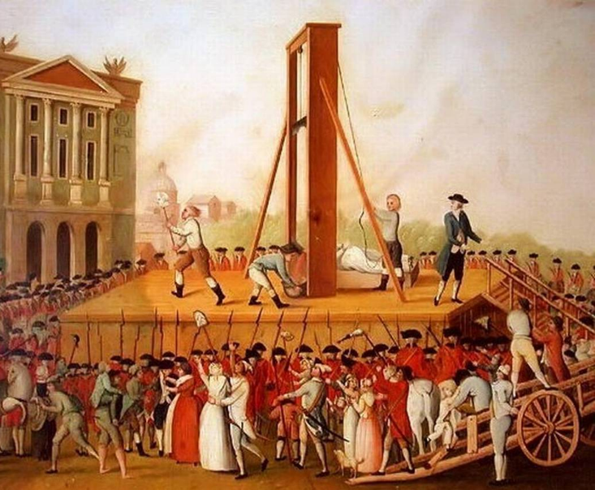
Democracy gives freedom from imposed authority. The people decide. It is no coincidence that Charles Darwin, son of a clergyman, himself an Anglican published the Origin of Species at the time of the era of European Revolution. It was a time to throw off all shackles, all restraints. Just as the guillotine had dispatched unwanted rulers and priests, so the theory of evolution beheaded the authority of God. Democracy “a government of the people by the people and for the people” – left no room for God. Instead, democracy leads to anarchism – anarchy which simply means without rulers' or 'without authority'. People do whatever they please – also known as Libertarianism. Every man does that which is right in his own eyes. - A quote from the book of Judges we will mention again soon. Worshiping freedom for freedoms sake. The French revolutionaries were consistent in their democracy. First it led to a kind of anarchism. Then the worship of Man. Then the tyranny of Man over Man.
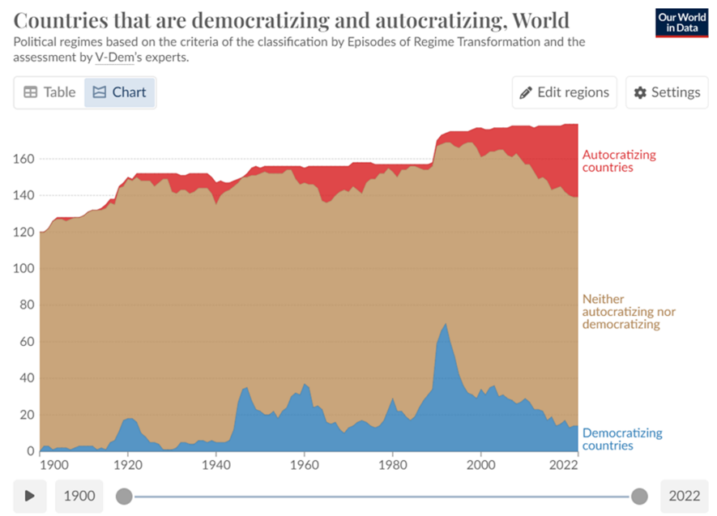
It is exactly what is happening with democracy today. Why - there has been a slew of groundbreaking laws passed across Europe, cutting across general standards of culture held for thousands of years – such as legislation for gay marriage, and now the Human Rights brigade insisting on LGBTQIA+ rights, where gender identification is to be regarded loosely, and anyone who does not tolerate such stupidity are themselves not tolerated by cancel culture and violence. The tyranny of man over man. It is why according to this graph, autocracy is now increasing across the world, and democracy is decreasing, as democracy always leads down to the lowest common denominator.
Seeing it was the translation of the Kings James Bible which was so instrumental in the understanding of the rights of man, the abolition of slavery, and accelerated the desire for democracy, let us turn to this book which has underpinned much of the tenets of the society in which we live today.
We will see modern democracy is nothing new or its faults and failings.
History of democracy government in Bible
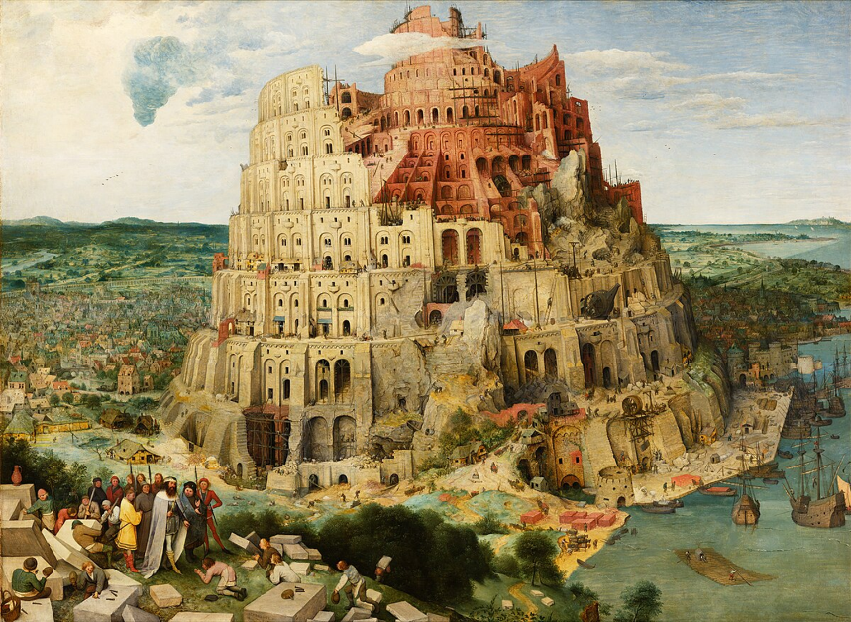
Tower of Babel
The book of Genesis relates the history and rise of early civilisations, but the first time we read of people power is sadly in a negative sense. Genesis describes a great migration of many peoples to the region of Mesopotamia, communication was unrestricted in that early society, all of one common language, they united together to build a huge edifice out of brick, an enormous tower, they idealised it would reach to heaven, to the place of the gods they supposed, connecting together, the idea was to create a name or reputation to give them social cohesion as the Bible describes it lest we be scattered across the earth… In fact what they were doing was joining forces to overthrow any higher authority, excluding any mention of the Creator in their thoughts and intentions. There could be no conceivable power or authority superior to theirs. Ultimately the democratic project proved to be their downfall, as what they set out to achieve became the cause to bring upon them exactly what they feared, they did splinter into separate languages, migrating rapidly away in fear of one another. The whole enterprise was called Babel meaning in Hebrew confusion.
Nation of Israel in Exodus
In the book of Exodus we are introduced to a nation that God chose to set an example to the rest of the world. Israel as a nation had been rescued from a tyrannical dictatorship, and were migrating to a new promised land. In this their early beginnings they were a theocracy. They accepted that their supreme authority was God. They were given laws from God. Even though a ruler as such was given to them in the form of Moses, and his brother Aaron as the High Priest, they both were representatives of the higher authority. The nation enjoyed a highly organised and stable period as a nation, where the population grew and upon entering the land of Canaan, successfully populated and cultivated the land. The nation consisted of 12 tribes who were in coalition, and cooperation together, all under the Supreme authority and rulership of God. The affairs of state, law and religion were one. Spiritual guidance and teaching underpinned every aspect of social life. The military aspects were local and voluntary. This contrasted sharply with the surrounding neighbouring tribes who were undisciplined autocracies, whose people were directed by the whim of a rich sheik, with little centralisation, whose social fabric was unsophisticated, and lacked continuity, this forced those cultures to be aggressive hostile and protective because they felt vulnerable to Israel’s purposeful and solid united society.
The first six books of the Bible describe the development and successes of this theocracy, and the superiority of such a system included many benefits and blessings, and at the same time, a departure from such a disciplined and regulated society would bring many disadvantages and curses, as detailed in chapters such as Leviticus 26 and Deuteronomy 28. Within this theocracy, elements of controlled elected democracy were permitted, to manage self-organisation. In Exodus 18, Moses’ father in law advised him that he could not possibly sit as judge on all the matters of the nation, it was physically impossible for him to do justice to the burden of such a responsibility. He had to delegate. thou shalt provide out of all the people able men, such as fear God, men of truth, hating covetousness; and place such over them, to be rulers of thousands, hundreds, fifties, and tens: And let them judge the people at all seasons: and it shall be, that every great matter they shall bring unto thee, but every small matter they shall judge: so shall it be easier for thyself, and they shall bear the burden with thee. If thou shalt do this thing, and God command thee so, then thou shalt be able to endure, and all this people shall also go to their place in peace. Moses followed this advice, and it became part of the nation’s organisational structure. But this sharing of responsibilities was in no way a denial of the supreme authority – they had to be men who had faith in God, who were not easy to bribe – hated covetousness and had to be men of truth. This is a key point, and it was these characteristics which were the qualifications for men who were given this power. They were not voted in by the people on the basis of lobbying skills, or how good their career had been, or how good they were at being social climbers!
Period of the Judges
The time of the judges saw a gradual breakdown of the political system of theocracy. The disadvantages of ignoring a supreme authority described as curses began to be fulfilled. Gradually people lost sight of the fact that the rules of their society were based on the rules set down by God, to function smoothly without disorder and breakdown. Leadership, corrupt and flawed, was viewed as being in the hands of the priesthood, or the elders, the tribe leaders. The tabernacle, the place of worship God had designed to be set in the centre of the nation as their focal point began to be abandoned. The sense of unity fell away. Instead of love and loyalty to God, loyalty became focused just on the tribe and then just the family unit. The nation became decentralised, tribes stopped supporting one another., and envy and competition arose between the tribes. Victories against enemies were local and temporary. In fact, an abandonment of the Divine rules was celebrated and sin rejoiced in. This period of 400 years can be described politically as anarchy, with small interludes of autocracy, where a strong Godly judge would attempt to reform the nation. At the end of the book we read in Judges 21:25 In those days there was no king in Israel: every man did that which was right in his own eyes. What we see here then is again, an rejection of supreme authority, followed by a breakdown and scattering of society.
Period of the Kings
Israel as a nation became fed up with this cycle of short term peace and long term violence, and they demanded that a new system of government be put in place. They wanted a king, a monarchy. To them this was the answer. It was not the solution. Because they still wanted to reject supreme authority, and wanted a king they could influence. As the Lord God pointed out to Samuel the Judge at the time: 1 Samuel 8:7 And the Lord said unto Samuel, Hearken unto the voice of the people in all that they say unto thee: for they have not rejected thee, but they have rejected me, that I should not reign over them. The disadvantages of having a monarchy compared to a theocrasy were pointed out to the nation in the same chapter: 1 Samuel 8:11-18. …This will be the manner of the king that shall reign over you: He will take your sons, and appoint them for himself, … … And he will take your daughters to be confectionaries, cooks, and bakers. And he will take your fields, and your vineyards, and give them to his servants. And he will take the tenth of your harvest and give to his officers. And he will take your … young men put them to his work... And you shall cry out in that day because of your king which ye shall have chosen you; and the Lord will not hear you in that day. And so it turned out. The result was a centralised power, a military industrial complex with loss of freedoms and taxation as the system became a monarchy. Oppression of the people, and a two-tier society. Saul the first king proved to be a great warrior but mentally unstable, David who feared God greatly proved to be a good leader, but was involved in much violence, Solomon expanded the empire but personal behaviour and tax regime was so reprehensible that it caused a permanent schism in the tribes, where the tribes in the north separated from Judah and Benjamin. A division and a scattering because of the rejection of the Supreme authority
Division in Israel Siege of Lachish by Assyrians
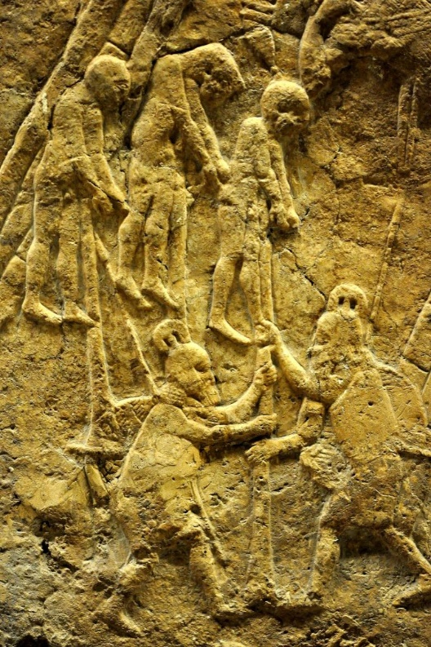
This division led to a period of consecutive invasions and assassinations and instability depending on the personal integrity of the king in both kingdoms, reverting the system of governance back to that of the time of the judges.
At no time in the history of Israel do we see them adopting a democratic system, instead monarch or anarchy seemed to be the only systems apart from theocracy. Because Israel rejected God as being their supreme authority, and wanted to be like all the other nations, they were permitted to be like the other nations, and suffered successive invasions and oppression from surrounding empires, which gradually completed absorbed the nation in its various forms into their empires. They were sent many prophets by God who warned them that self governance would always lead in calamity: Jeremiah 10:23 O Lord, I know that the way of man is not in himself: it is not in man that walks to direct his steps. If monarchy, and anarchy didn’t work how does democracy? Same people.
Subsequent empires
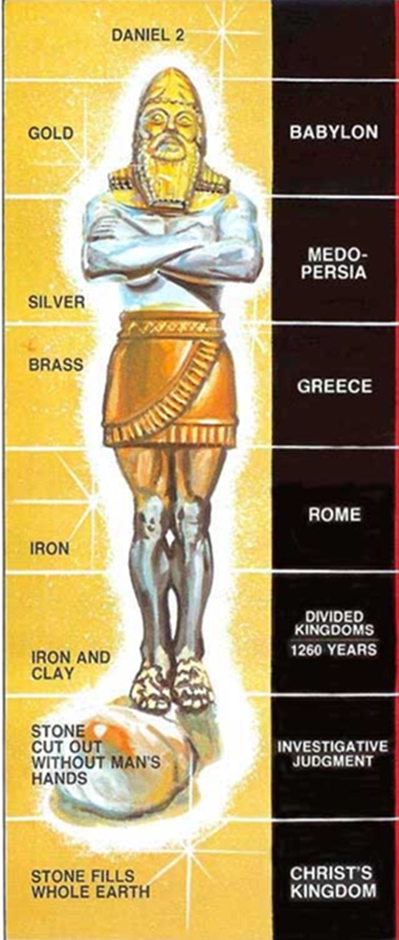
As the various empires began to overtake the region, one particular prophet which was sent to teach the exiled Jews was Daniel. He was given a gift to interpret dreams and the king of Babylon had a complicated dream that he wanted to know about. Daniel explained the dream of a huge image of a man standing which had a head of gold chest and arms of silver, and belly and thighs of bronze and legs of iron, and the feet were made of iron, but mixed with clay. He explained that each of these sections of the image represented successive empires one which would follow another. But that as soon as it was standing a stone came along and smashed the image on the feet, and the whole thing collapsed and was destroyed. Daniel was a Jewish prophet, and the dream concerned the Jewish people, and the image related to empires which would suppress the Jewish people. The first, the head of gold represented the Babylonian power, the second, the silver represented the Persian empire, the third the bronze section the Greek empire. The legs of iron spoke of the Roman empire, the East and West. The feet did not speak of an empire, but a coalition of kings, which had Roman influences – the iron, but mixed with the clay which speaks of the basest elements in man. What is interesting in relation to the talk this afternoon, is that each part of the image is in a process of declining value, from the head to the toe. From gold down to iron and dirt. The succession of empires had a sequence of methods of government, each in declining value of method of effectiveness and control.
Daniel pointed out in his revelation of the dream that at the very top, is God, who sent the dream to Nebuchadnezzar as the Supreme Authority. It is He who has predetermined the history of men. A fact which is rejected by atheists who deny even the existence of God. Daniel 2:21 21 And he changes the times and the seasons: he removes kings, and sets up kings: he giveth wisdom unto the wise, and knowledge to them that know understanding: The very existence and fulfilment of this prophecy proves that there is a God, as each empire has risen and fallen exactly as the prophet described.
The empires succeeding Babylon were inferior to Nebuchadnezzar’s head of gold, in the sense of their centralization of absolute power. Babylon, the head of gold, was an absolute autocracy. Persia, a monarchical oligarchy with the nobles equal to the king in all but office, is represented by silver. Greece is set forth by brass, indicated the still lower value of its aristocracy of mind and influence. Although it was the Greeks who fine-tuned the notion of democracy, it was not used to govern the empire. The empire of Rome which lasted a thousand years in various guises, its systems of government included a republic with an elected senate and consuls, a very early form of democracy, although this was overtaken by the cult of the emperor who brought back autocratic power, the ideas of democracy had taken root.
The last empire
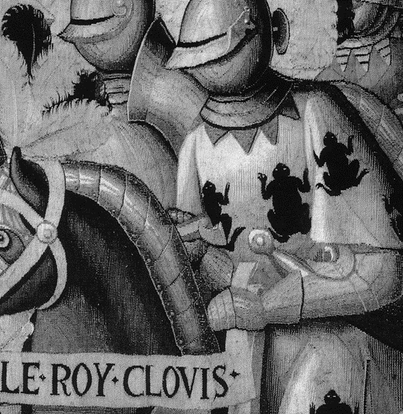
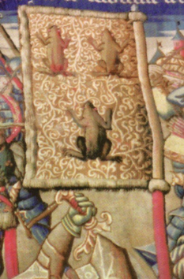
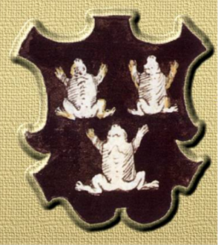
What of the feet and ten toes? Part iron and part clay and dirt? As history has revealed, the Roman empire lingered on for a considerable length of time in the form of the Holy Roman Empire, whereby the religious head, the Pope was the supreme authority, and control of the people was carefully managed, for example by Latin being the language of religion, and law. Self-rule and self-government was not permitted. Such a figure head was prophesied in the New Testament 2 Thessalonians 3 Let no man deceive you by any means: for that day shall not come, except there come a falling away first, and that man of sin be revealed, the son of perdition; Who opposes and exalts himself above all that is called God, or that is worshipped; so that he as God sits in the temple of God, shewing himself that he is God. Even today, there is still a Pope, head of the Catholic church, the largest and oldest man-made institution in the world. This is the iron in the feet and the ten toes. As we mentioned before earlier, the knowledge of men suddenly increased enormously and their minds were freed from the iron-like grip of the power of the church, when the Bible was made available in native languages, and self-rule, democracy was craved by the people, rebelling against any form of supreme authority. The Holy Roman empire broke apart but remained as a coalition joined by Roman Catholic ideology, but became nation states forming modern Europe, democratic powers. Power was decentralised. Modern Europe as we know also oppressed the Jews more mightily than any empire before, under the system of democracy where the majority is always right, where Communism caused countless pogroms against the Jews, and popular Nazism caused the murder of millions of Jews. Oh yes, the Nazis were voted in at the ballot box. This the weakest form of governance bringing out the worst of man is represented by the iron and clay and the ten toe kingdoms. Daniel said Daniel 2:44 And in the days of these kings shall the God of heaven set up a kingdom, which shall never be destroyed: and the kingdom shall not be left to other people, but it shall break in pieces and consume all these kingdoms, and it shall stand for ever. Again the pattern is repeated a breaking in pieces of the ideas and power of man. In the book of Revelation and chapter 16 prophesied 16:13-15 And I saw three unclean spirits like frogs come out of the mouth of the dragon, and out of the mouth of the beast, and out of the mouth of the false prophet. For they are the spirits of devils, working miracles, which go forth unto the kings of the earth and of the whole world, to gather them to the battle of that great day of God Almighty. Behold, I come as a thief. Blessed is he that watches, and keeps his garments, lest he walk naked, and they see his shame. This presentation is not about an exposition of this last book of the Bible, but democracy - and so the context of these verses we will just summarise, as the Lord Jesus is describing the political and religious conditions which will exist just before he returns to the earth - as that little stone power to break and destroy the kingdoms of men. SLIDE 27 He describes how three unclean spirits like frogs came out of the mouth of the dragon, beast and false prophet. This is symbolic language describing spirits or doctrines like frogs being uttered from the dragon, that is influences from ancient pagan Rome – the belief that people can worship any god they want to, or liberty from the beast, that is influences from the Holy Roman Empire which taught the brotherhood of man – fraternity, and influences from the false prophet the Papacy who champions human rights – equality. As we began this talk, these three aspects liberty, fraternity and equality was the shout of revolution, which in Europe started in 1789 at the storming of the Bastille in France, and the beginning of modern democracy. Of course, the frog is well known as being the heraldic symbol of the

French people. What is peculiar about the frog is its life cycle, where it changes shape and habits, but is still the same, just as democracy does in all its forms. As we have seen with the image that Nebuchadnezzar saw in his dream of the different governments of man, changing but always the same. It is what can be said of democracy. It is based on religious ideology, it came from religious teachings – but has been mingled with humanism, atheism, Darwinism, it has many forms, where human rights trumps all other moral considerations, and there is no higher authority than the common man himself.

The Life Cycle of Democracy
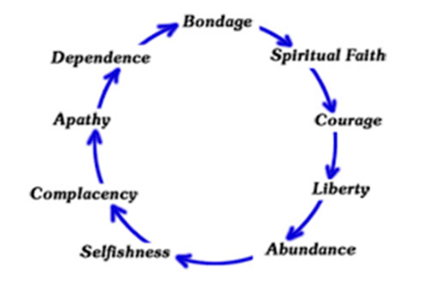
It is this spirit of democracy which is epitomised in the project of the European Union, mingling but not cleaving, a fragile coalition of democratic mostly Roman Catholic states. A system of governance where democracy has so developed where the nations have unsuspectingly ceded sovereign power to an unelected central power. Again, the pattern seen in the Bible is being repeated where man convinced he can govern himself is building a tower to reach unto heaven, to be a major world power making a name for himself, denying supreme authority, denying that the God who gave them the founding ideals even exists, so that every man does that which is right in his own eyes, and so the next step in the process is anarchy, where equality of rights is taken to extremes and laws and norms of society are broken down, and as at the tower of Babel, the project was destroyed people scattered, and this last empire which has methodically oppressed God’s people for centuries will also be destroyed and will be broken into pieces.
Conclusion
The Bible has made clear man’s inability to rule himself, as shown in the history of Israel. History has revealed the fatal flaws of democracy. Even Winston Churchill said democracy is the worst form of government except all the other forms which have been tried. Democracy is not a biblical practise as it involves the idea of human beings making decisions based on their own preferences and desires rather than seeking guidance and direction from God. Sayings we hear today – I am my own God… Oh my god…be true to yourself…The candidates put forward for election are just products of the society they serve, there is no higher aspiration, lowering standards to greater depths like hibernating frogs. The Bible utterly condemns such ever moving – and descending standards. Deuteronomy 12:88 Ye shall not do after all the things that we do here this day, every man whatsoever is right in his own eyes. With a democracy the majority is always assumed to be right, but Jesus said Matthew 7:14 strait is the gate, and narrow is the way, which leadeth unto life, and few there be that find it. Luke 12:32 Fear not, little flock; for it is your Father's good pleasure to give you the kingdom. Delegation of rule to men is only possible as we read in Exodus 18, when they are such as fear God, men of truth, hating covetousness. And since when has that been the case?
It is for this reason, those who believe the Bible is the word of God look to Him to be the Supreme Authority, and accept He has delegated power to His Son Jesus Christ, who is the Head of their Society, the Ecclesia, which means those called out. It is a theocracy, a Kingdom in waiting, it is the Kingdom of God, which will include the reformation of Israel, the end of the Kingdoms ruled by tyrants and autocrats, they will be broken in pieces, and the Kingdom of God will grow in size and influence, until it will completely dominate the world, all nations will surrender and submit to His rule. But for now, the Ecclesia continues, organising itself on godly principles. There is no pope in the true church. The hierarchy which exists is God, Christ, Members. All are to submit to one another, all to aspire to be shepherds. They are citizens of another country, and swear allegiance to another king who is to return to earth. Philippians 3:20 For our citizenship is in heaven; from whence also we look for the Saviour, the Lord Jesus Christ: However they still pay taxes Romans 13:1-7 Let every soul be subject unto the higher powers. For there is no power but of God: the powers that be are ordained of God. Render therefore to all their dues: tribute to whom tribute is due; custom to whom custom; fear to whom fear; honour to whom honour. They still keep the laws of men, until such time as they contradict the law of God, as Peter said Acts 5:29 We ought to obey God rather than men. They also vote! Yes, using an aspect of democracy which can be useful. The difference is that before they vote for an elder into service of the ecclesia, they all pray. They examine the character of the individual, and ensure that all things are done decently and in order. Prayer before the ballot-box! the idea is this country is just laughable. Within the ecclesia consensus is always sought as much as possible. Elders do not receive any privileges, all are treated as equals. There is no partiality to the poor or deference to the rich, there is no judgement of intent, but only of actions. There is no bullying or lobbying, but transparency is the rule of the day. Jesus said in Luke 22:25-27: The kings of the Gentiles exercise lordship it over them; and those in authority over them like to be called ‘friends of the people’. But not so with you; rather the greatest among you must become like the youngest, and the leader like one who serves. Instead of leading from the top, they are to lead by serving. Every member only achieves unity, not by arguing and contending, and who is the loudest, but by what the scripture says. That is the highest authority. It is this authority which has been rejected and replaced by the false mirage of democracy, it is the Supreme authority and leadership of God which has been denied, which has caused the irreversible moral slide and fracturing, and breaking of society –
But not for long, as the image teetering on its unstable foundation of the iron and clay will be helped on its way to self-destruction by the just judgement of Jesus Christ, and the anarchy of men will be replaced by the order and love of God. May He hasten the day.
Dartford Apostolic Ecclesia
25th February 2024

