Bible Teaching on
Forgiveness

The idea that people have of Christianity today, is to be forgiving. This is true, but there is something more fundamental than that, that the Bible teaches, is that we all need to be forgiven. So in this booklet there are several areas we would like to look at:
- Why is there a need for forgiveness?
- Forgiveness from what?
- Are there conditions for forgiveness?
- Then we will look at forgiving others – even as we have been forgiven.
Why is there a need for forgiveness?
Jesus taught his followers to pray, and included in the prayer are:
Luke 11:4 …And forgive us our sins; for we also forgive every one that is indebted to us. And lead us not into temptation; but deliver us from evil.
The Bible is very clear … with forgiveness there is an order of importance… Getting right with God is more important than getting right with people.

Normally when we offend people, we also offend God, when we offend God, often people will not be involved, so always it is God who is wronged. Why is this? It is simple which we all know, and it is introduced in the first few chapters of Genesis. Man chose of his own free will to ignore the commandment of God and to disobey, despite being warned of the consequences.
What is the effect of sin?
Paul answers this quite simply: Romans 5:12 Wherefore, as by one man sin entered into the world, and death by sin; and so death passed upon all men, for that all have sinned: The effect of sin is death. It was the curse placed upon man in the beginning. Genesis 2:16. And the Lord God commanded the man, saying, Of every tree of the garden you may freely eat: But of the tree of the knowledge of good and evil, you shalt not eat of it: for in the day that you eat thereof you shalt surely die. That was what God said in the very beginning. He placed restrictions. Man was not God’s equal. He still isn’t. He is not in control of his own destiny. God is. He cannot do as he wants. God’s restrictions still have not been lifted. God made it quite clear. Disobedience would end in death. Thus God said to Adam, and to all of his seed, In the sweat of thy face shalt thou eat bread, till thou return unto the ground; for out of it wast thou taken: for dust thou art, and unto dust shalt thou return.
What is sin?
What is sin? This is the word that Jesus uses in Luke 11 in the prayer he taught his disciples. Forgive us our sins. It means missing the mark. All have missed the mark. The Apostle Paul says For all have sinned, and come short of the glory of God.
All have come under the curse. All inherit a sinful nature. All are subject to death. As a result of our nature we continue to disobey, are thus offend God on our own account, and not just because we are sons and daughters of Adam. We are responsible for the breach, we cause the displeasure of God. We offend him, just as Adam did. Has God’s purpose been cut across then. Because we miss the mark, does it mean that God’s purpose has been thwarted? Has man’ disobedience spoilt God’s purpose with man for ever? No. God’s purpose with the world, and man upon it will still be fulfilled despite the disobedience of man. God is infallible, his Word unalterable. As the prophet said: Isaiah 46:8 Remember this, and shew yourselves men: bring it again to mind, O ye transgressors. Remember the former things of old: for I am God, and there is none else; I am God, and there is none like me, Declaring the end from the beginning, and from ancient times the things that are not yet done, saying, My counsel shall stand, and I will do all my pleasure: The character of God does not, cannot change.
In Hebrew there are at least eight basic words: ra, bad, rasha, wickedness, asham, guilt , chata, sin; avon, iniquity; shagag, err; taah, wander away ; pasha, rebel. In the Greek New Testament, there are even more words: Kakos, bad; poneros, evil; asebes, godless; enochos, guilt; hamartia, sin; adikia, unrighteousness; anomos, lawlessness; parabates, transgression; planan, to go astray; paraptomai, to fall away. However the most common by far is hamartia meaning to miss the mark

God has established His standard of perfection and approval, and all men have “missed the mark” as an archer’s arrow would fall to the ground because it fell short of its target. God is omnipotent. He is all powerful. He is the great Creator. God has set the creation in motion. He does not change. He cannot change. His will, his decisions will be fulfilled. However, sin, missing the mark. Transgression, cutting across, man has transgressed and sinned, he has cut across God’s will,. He has missed the mark of God’s standard, he has rebelled against God’s decision and revolted against God’s purpose. Thus we can see that sin, is the contradiction of God’s will. It is simply disobedience. It is an attempt to reverse God’s plan of action. Man has challenged God. His actions of contradiction are opposite to all that God stands for. That is righteousness, faith, justice, moral goodness. Sin is opposite to all that. Surely, we can all see then why God does not like sin. Why man’s attitude has made him unhappy, why sin so offends Him.
Is it the end then?
He was a compassionate and gracious God when he created man, and he was and still is a compassionate and gracious God after Adam sinned. This was seen straight away in permitting Adam and Eve to carry on living a long and productive life, even after they had been condemned to death. God had said dying thou shalt die, but in the event, He in His compassion and mercy gave them an opportunity to live! His character cannot be cut across. He has provided a way for mankind to be at one with Him again. Sin can be overcome, and death can be overcome, so that it can have no power on a man. The effects of sin can be reversed by the sins being blotted out of God’s book of life, of the sins being covered up, as if they were not committed. However is this possible then?
Man has offended God on two counts. One: his sinful nature he inherited from Adam, and two: his own sins, his own selfish actions that he chooses of his own freewill to commit, his own disobedient and rebellious conduct. For the first offence, God has provided a way for all men to be released from the curse of death. The Apostle explains: 1 Corinthians 15:21. For since by man came death, by man came also the resurrection of the dead. For as in Adam all die, even so in Christ shall all be made alive. But every man in his own order: Christ the firstfruits; afterward they that are Christ's at his coming. As Adam disobeyed, Christ the second Adam, obeyed. Although Christ was under the curse of death, he never sinned. He didn’t offend God on his own account. Thus, when he died he paid the price, he obeyed the curse, and once dead, the curse no longer had any hold over him. God simply raised him up from the dead again and gave him life eternal.

How does all this then help us men and women, who do sin, and have offended God? Well, it means that if we join ourselves to Christ, and follow him, and follow his life, then the curse of Adam will have no hold over us, and we too can be resurrected from the dead. Our sins which we have committed can be blotted out, covered over, by the sinless life of Christ who died to fulfil the curse, pay the ransom, pay the price of Adam’s transgression. Our sins, which we have committed, and offended God on our own account can be forgiven.
What is forgiveness?
We have looked at sin, and its effects. But what of forgiveness? What is forgiveness? It is to forgo revenge, forget giving back in injury. To accept the hurt. To waive reparation. So what is forgiveness then? When we have two people, and one has upset the other for whatever reason, one of the people have become offended. As a result, the relationship has been damaged. Feeling have been hurt, one party injured. A gap has arisen, a breach then needs to be healed. The person who is offended can insist on the other person doing something to make them happy again. Or on the other hand they could simply say, oh look don’t worry it’s fine, I can get over it.
One dictionary description is this: to grant pardon for or remission of (an offense, debt, etc.); absolve. 2. to give up all claim on account of; remit (a debt, obligation, etc.). 3. to grant pardon to (a person). 4. to cease to feel resentment against: to forgive one's enemies. 5.to cancel an indebtedness or liability of: to forgive the interest owed on a loan.

Case Study
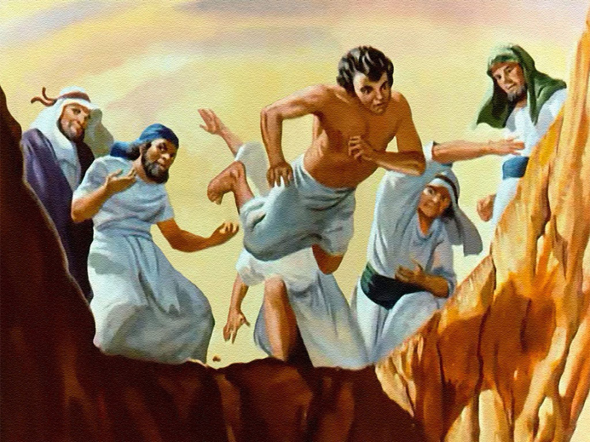
With all Bible teachings and doctrines there are always examples and case studies.
Take for example Joseph, the young brother who made the rest of his brothers mad, because of he was his Dad’s favourite. They grabbed him one day, stripped him of his special coat his father had made and threw him into a disused well. They then changed their minds and sold him into slavery, and lied to their terribly distressed father, that a wild animal had killed and eaten him. This episode depicts these bunch of men as being jealous, insecure, hard-hearted cruel, sadistic, selfish liars. They were content to sit on those lies for years. Not one of them owned up. Yet somehow through them came the Promised Seed, God used them for His purpose. Those bunch of horrible people were in fact supposed to be God’s elect. How did they manage to turn around their lives?
Through the person of Joseph, who God used to transform them, to enable them to be forgiven. It was not a straightforward job. Thise men had to prove that they had changed. Forgiveness was not without conditions. It had to be seen that they had repented and were no longer spiteful, but caring. Words like simply saying sorry were not enough. Through a process that Joseph worked out, which we can read at our leisure, Joseph could see that his brothers had changed, and he then freely forgave them. They did not continue to beat themselves up over their past. They acknowledged they were wrong, and that the terrible events which had befallen them, were actually a good thing, and that all these things worked out for the good. After that they all lived in peace – with one another and with God.

A second case study is David, the king of Israel. This man was famous for writing many of the Psalms, of subduing the enemies of Israel, and uniting the nation together. But in the matter of Bathsheba described in 1 Samuel 11, also he was an adulterer, philanderer, he was a liar. He was a deceiver, he was a murderer. Yet of him it is said in the Bible that he was a man after God’s own heart. Through him came the promised seed, even he that was born of the virgin Mary, a direct descendant of David, even Jesus Christ the son also of God. The Promises made to Abraham, Isaac and Jacob were confirmed to David, and described in the New Testament as the sure mercies of David.
How did a person who was capable of such wicked behaviour still end up regarded as righteous, and is even mentioned in Hebrews 11 as being a role model of someone of Faith? It was because he was Forgiven.
But that was not a straightforward process. It took quite a few months after the terrible events, before the realisation struck home, and David was confronted with the truth through the words of an old friend. He was devastated. He accepted the punishment given to him with meekness and remained a humble man the rest of his life. We have read together the Psalm he wrote when he realised what he had done. It is one of the most moving passages in scripture as it is so true to life, our own human experience
Forgiveness is not unconditional
The Scripture always gives us true life examples and case studies. It is a book of truth, and why its words resonate with our own conscience. We are in constant need of forgiveness, over little things as well as big. The problem is with human nature, is that as their nature is sinful they tend to sin a lot. God is not mocked. He is a God of justice and equity.
Some people believe that once saved you are always saved, that once you have received Jesus, that no matter what you do after that, you will still be saved. “No matter how many times you sin, God will always forgive you, after all He is a God of love”. But men who believe such things are deceiving themselves.

This attitude is no different to Joseph’s brothers who carried on after getting rid of their brother, as if nothing had happened. It is no different to David who tried to cover his tracks. No different to Judas who betrayed Jesus, and was too proud to say sorry. Romans 10:3: For they being ignorant of God's righteousness, and going about to establish their own righteousness, have not submitted themselves unto the righteousness of God.
Need for repentance
Repentance – In Hebrew there are two main words used in the Bible 1: schuwb which ,means to turn back, and nacham which means to sigh or be sorry. In the New Testament, the word repent in Greek is metanoia – to think differently, to reconsider, to change the mind.
Interestingly, our English word comes from the Latin, which means to creep, prostrate, rooting, and comes from the same origin as the word pain. Penitence which is part of Roman Catholic teaching also comes from the same group of words. In fact, the Bible does not teach the need for ritual penitence. The Churches have maintained that to be forgiven confession is made to a priest, and a price has to be paid, either money to the church or in the medieval times, self-flagellation or public humiliation. But there is no price big enough to undo the damage caused by sin.

The Scripture teaches there must be a change of mind.
Confession
Repentance involves an acknowledgement – in the form of confession in prayer to God. It involves recognition of the root causes of that sin, and a change of direction to follow.
1 John 1:9. If we say that we have no sin, we deceive ourselves, and the truth is not in us. If we confess our sins, he is faithful and just to forgive us our sins, and to cleanse us from all unrighteousness. “Forgive us our sins”. Just four words, trips off the tongue quite easily. But there is more to it than that. God is looking for a change of heart. God is looking to see if the offender, the sinner understands that he has done something wrong, and wants to put it right. By confessing sin, and acknowledging it, it shows that you understand and recognise that you are transgressed, that you have offended God, and you are angry with yourself because of that. When God sees this, He can see that the sinner hates sin as well. It means that God and they have something in common. This commonality is the basis of a friendship. Friends understand each other - friends forgive. For man then to recognise when he fails, that oh! he has sinned again. If he shows the disappointment in himself that God does. If he is mutually angry at that failure, then God will help him put it right. This whole attitude, is seen in the passage that we read together, Psalm 51. Have mercy upon me, O God, according to thy loving-kindness: according unto the multitude of thy tender mercies blot out my transgressions.
It is not possible to receive forgiveness of sins if there is no acknowledgement, and to fully understand what we have done to offend God, and then others. We need to notice this. When David sinned, he sinned against Bathsheba, his own wives, he sinned against Joab, and especially against Urijah, who he had murdered. But in his confession we read: Psalm 51:3,4 For I acknowledge my transgressions: and my sin is ever before me. Against thee, thee only, have I sinned, and done this evil in thy sight: that you might be justified when you speak, and be clear when you judge. Always it is God that is offended even when we sin against others. It is God who has made the rules after all.
God of mercy
Here we see that we should remember that God is indeed a God of mercy. We are not so bad that we cannot be forgiven. The Psalmist wrote too that God knows our frame. His own son, was made of the same passions as we, made of the same nature. He too took part of the same, and so is a qualified go between, an intercessor, who says the Apostle in the Hebrews Wherefore he is able also to save them to the uttermost that come unto God by him, seeing he ever lives to make intercession for them. Isaiah 55:7 Let the wicked forsake his way, and the unrighteous man his thoughts: and let him return unto the Lord, and he will have mercy upon him; and to our God, for he will abundantly pardon. God can and is willing to blot out sins. Wipe them out as if they have never been committed. Psalm 103:12 As far as the east is from the west, so far hath he removed our transgressions from us.

Need for a contrite heart
Yet we cannot take this for granted. Grace is not ours by right. God will only blot out if He sees a repentant heart. 2. Wash me thoroughly from mine iniquity, and cleanse me from my sin. This is a consistent plea. We can see this prayer is from the heart. The prayer he shows that the sinner recognises he has tarnished his character and sullied his reputation. He is unclean in God’s sight and needs to be washed by allowing the water of God’s word to heal, by appreciating that the sinless life of Christ Jesus has been offered as a covering, and that his blood cleanses us from all sin. Yet again we see the way the sinner – in this case David the King of Israel who should have known better, just like us, who was not ignorant, but deliberately committed terrible sins, yet we see his mind: 3. For I acknowledge my transgressions: and my sin is ever before me. I acknowledge my sin… Here we see it then. Acknowledgment. Owning up takes courage.
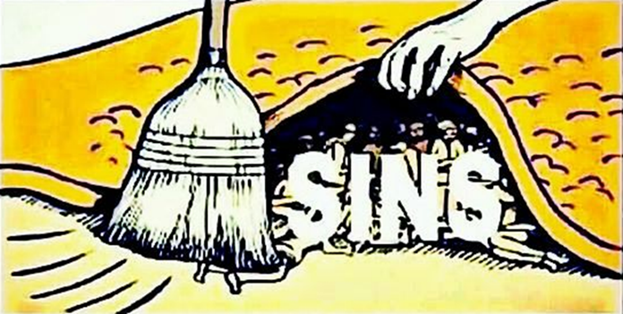
Before we can own up to God, we have to own up to ourselves? We have to admit we have failed to ourselves. We must see that we are guilty before God. We cannot cover it up. Proverbs 28:13 He that covers his sins shall not prosper: but whoso confesses and forsakes them shall have mercy. Numbers 32:23 23. But if ye will not do so, behold, ye have sinned against the Lord: and be sure your sin will find you out. We read there in verse 3 didn’t we – my sin is ever before me. This is guilt. When we are guilty it is the knowledge of the word of God working in us. We should listen to that guilt, before we do the sin, not afterwards. We do feel guilty, afterwards we feel terrible. But how does God feel, He who has given us everything we need to overcome sin , including the example of His own dear son. Our sin is before Him also. It is offensive to Him. He cannot look upon sin, this we have put ourselves away from him. We are not with him, but against him.
Only God can forgive and make right
Only God can cleanse us. We cannot do it ourselves. God has provided the only way. This was the Apostle teaches us: Hebrews 9: 14 How much more shall the blood of Christ, who through the eternal Spirit offered himself without spot to God, purge your conscience from dead works to serve the living God? And again 1 John 1:7 But if we walk in the light, as he is in the light, we have fellowship one with another, and the blood of Jesus Christ his Son cleanses us from all sin In verse 9 of Psalm 51 we read: Hide thy face from my sins, and blot out all mine iniquities. 10. Create in me a clean heart, O God; and renew a right spirit within me. 12. Restore unto me the joy of thy salvation; and uphold me with thy free spirit. Create in me a clean heart, renew, restore. We can add - repent! We see here the appreciation of a change of heart that we were talking about earlier. (No good just asking for forgiveness, like the Catholics do ‘Hail Mary’s’ what does a form of words do?)
Resolve to change
Prayers are empty and meaningless if there is no determination and resolve to do better, and learn by our mistakes. So verse 17. The sacrifices of God are a broken spirit: a broken and a contrite heart, O God, thou wilt not despise. David truly understood, God is not interested in great penances, or elaborate rituals like the wearing of rough garments, or flagellation, He is not interested really in the blood of bulls and calves or great sacrifices. What He wants to see is that repentance from the heart. A change of direction. So in the Psalm, clearly David does just that. Moving on from his transgression, no point is crying endlessly, sometime we have to move on, and show our faith, and trust that God will forgive. Our part is to prove we are sorry by working towards the goal that God has set us. His Kingdom. 18. Do good in thy good pleasure unto Zion: build thou the walls of Jerusalem. 19. Then shalt thou be pleased with the sacrifices of righteousness…

Forgiving others
Seeing then that God, has designed such a plan, such a purpose with man, such a plan of reconciliation. Seeing he has given hope to dying man, and shown him His mercy through the forgiveness of sins, for the sake of his Son Jesus Christ. Should not such a salvation be seized gratefully hold of with both hands. Why is it that men despise the mercy of God? There is a spiteful side of all of us, that we do well not to ignore. the natural man only thinks of himself, but the Bible teaches us that forgiveness works in two ways. A truly repentant person who understand, and loves the example of the Lord Jesus will know this. The man or woman who desire to be like God, who seek to emulate His character seen in Christ Jesus will know that forgiveness works in two ways.
To receive forgiveness we must be forgiving.
To receive forgiveness we must be forgiving. How we want to be treated is how we should treat others. If hold a grudge, why should we expect others why should we expect God to forgive us? Luke 6:37 Judge not, and ye shall not be judged: condemn not, and ye shall not be condemned: forgive, and ye shall be forgiven:
Jesus’ Parable
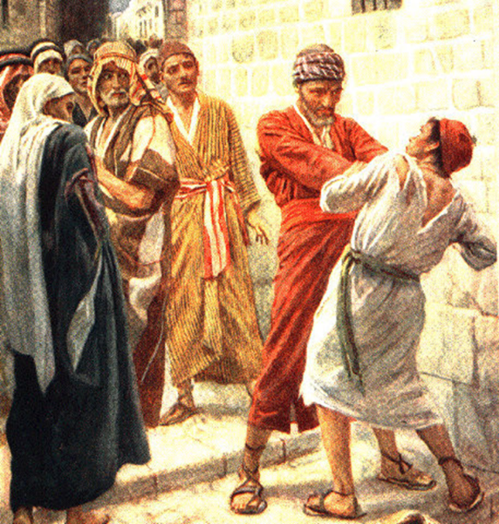
Jesus told a parable about this. There was this king who one day decided to check up on his servants. One of them proved to be a rather reckless chap who had spent the king’s money very foolishly, and owed him ten thousand talents, a massive sum of money in Jesus day. A lifetime’s earnings, - equivalent to 1 or 2 million pounds today. There was no way he could pay it back, so the king said, well I will sell your wife and children into slavery, and you to go towards paying that debt off. The servant therefore fell down, and worshipped him, saying, Lord, have patience with me, and I will pay you all. Then the lord of that servant was moved with compassion, and loosed him, and forgave him the debt. What a relief. The servant would have been amazed at such generosity. Saved. However, bolstered and over confident, proud of his new found favour he seemed to think he was the king, and he remembered that one of his fellow servant owed him a hundred pence. Just a trifling debt really. But the servant took him by the throat and demanded it back immediately and threatened to throw his fellow into prison and all that he had, unless he got that money back immediately. And his fellow servant fell down at his feet, and begged him, saying, Have patience with me, and I will pay you all. And he would not: but went and cast him into prison, till he should pay the debt. The king heard of this unjust and evil behaviour, and he called him, O thou wicked servant, I forgave you all that debt, because you wanted me to: Should you not also have had compassion on your fellow-servant, even as I had pity on you? And his lord was wroth, and delivered him to the tormentors, till he should pay all that was due unto him. So likewise shall my heavenly Father do also unto you, if ye from your hearts forgive not everyone his brother their trespasses. This was the very point that Jesus sought to emphasise in the prayer He taught His disciples. Matthew 6:14-15 For if ye forgive men their trespasses, your heavenly Father will also forgive you: But if ye forgive not men their trespasses, neither will your Father forgive your trespasses. Thus, asking for forgiveness from God, whilst at the same time showing a lack of compassion towards others, shows that we do not appreciate mercy and do not appreciate grace.

The need to be Gracious
If God gives grace to us, and yet we are spiteful to others and unforgiving, that grace would be meaningless, we wouldn’t appreciate it. How can we have a change of heart, if we show a meanness and lack of forgiveness to others. We are not a judge, it is not our place to hold a grudge. If anyone should be resentful, it should be God, not us. After all we spoiled His creation. Yet God does not hold a grudge. He forgives. Look at how many times He forgave his nation Israel, and still he has not cast them off, and has promised to cleanse them, once they show a change of heart, once they acknowledge their sin, and acknowledge the intercessor that God has given them, their Saviour Christ Jesus. Truly they will mourn and lament for the hardness of their hearts. It is true with us. How many times do we continually fail? We all have weaknesses, that we give in too. It is a battle. Yet we truly desire that God would forgive these our weaknesses. In the same way we should exercise patience and longsuffering to others, when they trespass against us. Matthew 18:21-22. Then came Peter to him, and said, Lord, how often shall my brother sin against me, and I forgive him? till seven times? Jesus saith unto him, I say not unto thee, Until seven times: but, Until seventy times seven. Some take these words literally. They miss the point. Rather they miss the mark, for forgiveness should not have a limit. Mercy says the scriptures rejoices against judgement. Patience and longsuffering, grace and compassion. Love.
These are the aspects that true disciples of Christ should display in their lives. God will show the same to them. They are becoming as Christ – as God. Ephesians 4:31-32 Let all bitterness, and wrath, and anger, and clamour, and evil speaking, be put away from you, with all malice: And be ye kind one to another, tender-hearted, forgiving one another, even as God for Christ's sake hath forgiven you, again Colossians 3:13 Forbearing one another, and forgiving one another, if any man have a quarrel against any: even as Christ forgave you, so also do ye. This then should be the mind, the life of all those who seek God in prayer. There is much to remember. We may already have forgotten some of them. One thing we must not forget, is that Jesus understands, he shared our nature, and knows our frailty. For such an high priest became us, who is holy, harmless, undefiled, separate from sinners, and made higher than the heavens; If we truly believe in him, and seek God, through the Lord Jesus, He will hear us, and He will answer us.. Ask, and it shall be given you; seek, and ye shall find; knock, and it shall be opened unto you:

